Have a look at our latest addition to the effort! This vehicle will be very helpful for our work with mission teams and school children in Merger, Haiti.
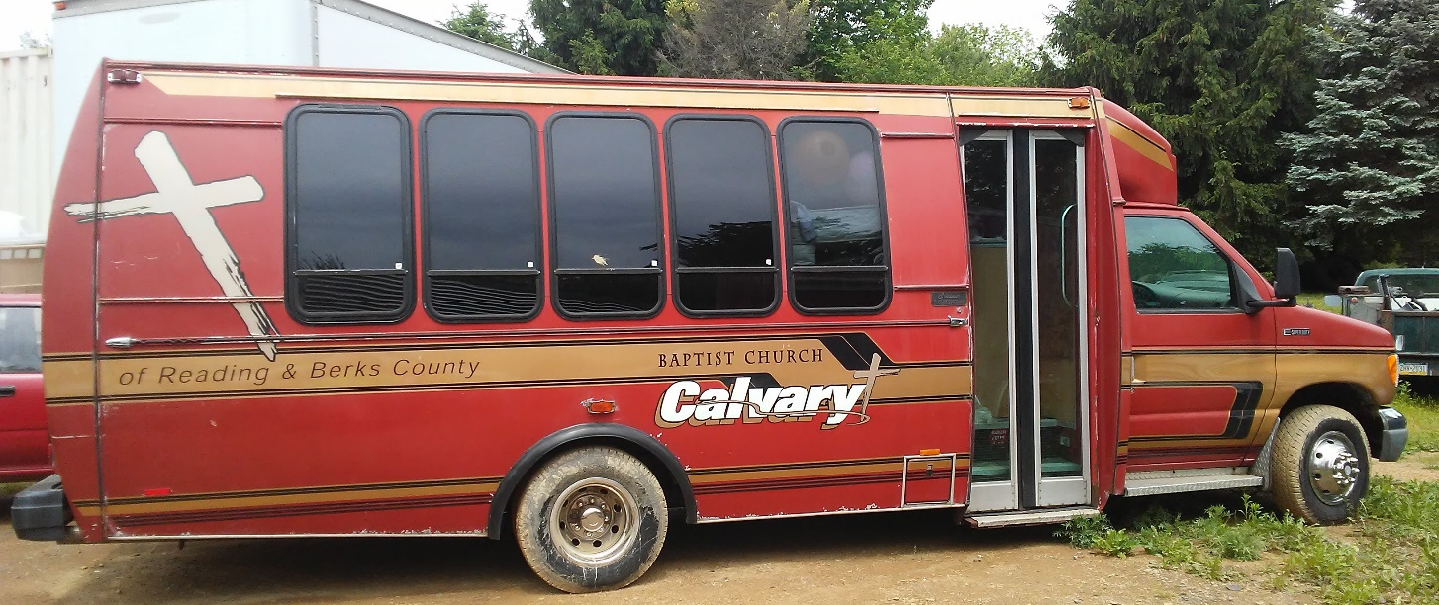
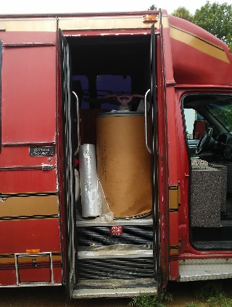
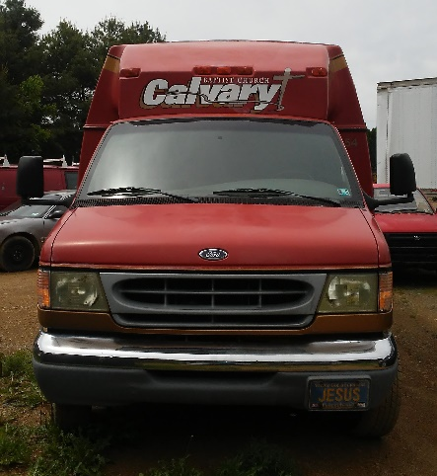
Packed full of supplies!
The Institute of Grace has received this vehicle through the Christian Missionary Technical Services (CMTS) in Pennsylvania. They have also provided many of the supplies in the vehicle, and have been a longtime supporter of our efforts in Haiti. We will be adding a few more supplies and transporting the vehicle to Florida for shipping in June.

We are also looking forward to our trip in June with the Church of the Redeemer from Temple Hills, MD. This team will be working with the Primary School and with pastors from the local area. In addition, we are working on solar power for the computer lab in the school. This will increase the availability of the computer lab for the students. June promises to be a busy month for us.
Please pray for our efforts. If you would like to donate toward the shipping of the bus, fuel for the trip to Florida, or ongoing support, any contribution will be greatly appreciated and can be sent to The Institute of Grace, PO Box 2364, Leesburg, VA 20177.
In His Service,
David Graves for the IOG; May 24, 2017

